Chlorophyll Fluorescence Demonstration TEACHER’S GUIDE
Photosynthesis

Background Information:
Chlorophyll is the green pigment in plants that absorbs light energy used for photosynthesis. A pigment is an organic compound that gives a characteristic color to a substance. Most plants appear green because chlorophyll reflects green light.

You may remember from physical science that visible light is the portion of the electromagnetic spectrum that humans can see. The “white” light we see from the sun is actually a combination of various wavelengths of light. When the light is bent or refracted, it separates by wavelength, and we see all the colors that collectively make up white light: red, orange, yellow, green, blue, indigo, and violet.

When chlorophyll is exposed to sunlight, it reflects the green wavelengths (and therefore appears green to us), but it absorbs red and blue wavelengths. So, it is actually red and blue light that powers most photosynthesis.

When photons of light strike the clusters of chlorophyll in plant chloroplasts, electrons in the chlorophyll molecule are excited by the light energy and jump up to the next energy level or electron shell. Then, when the electrons fall back down to the ground state, they release energy.

This energy is either used for photosynthesis, released as heat, or re-emitted as light. When the energy is re-emitted, this is called fluorescence. Fluorescence is defined as the emission of light by a substance that has absorbed light or some other form of electromagnetic radiation.

I am going to demonstrate fluorescence from chlorophyll. What color of light do you think we will see?

Notes:
- Chlorophyll fluoresces red because when it absorbs light (especially higher energy blue-violet or UV light), its electrons are excited to a higher energy level. When these electrons return to the ground state, they release a portion of that excess energy as a longer-wavelength, lower-energy photon in the red spectrum.
- Several methods can demonstrate chlorophyll fluorescence, but this is the one that has worked best for me.

Teacher Prep:
- Gather materials for each class:
- Equipment:
  - hot plate or microwave for heating water
  - thermometer
  - container for hot water such as Pyrex 1-cup measuring cup or 400-500 mL beaker
  - glass stirring rod
  - test tube, 2, about 16mm x 150mm or larger
  - small funnel that will fit into the test tube
  - black light (I used an Escolite UV flashlight from Amazon, $12.99)
  - test tube rack or holder
- Consumables:
  - spinach leaves
  - acetone
  - filter paper
  - water

2) Right before class:
- Prepare hot water using a hot plate or microwave. I usually do this in a Pyrex measuring cup or large beaker. You want to use hot water, but NOT boiling water. The boiling point of acetone is around 56°C (133°F), so use the thermometer to make sure your water temperature is at least 65°C, but no higher than about 80-85°C.
- Set up a filtering apparatus by placing the filter paper into the funnel and the funnel into one of the test tubes.

Directions for Demonstration
- Read the background information to students.
- Tear the spinach leaves into small pieces and add them to the test tube until it is about half full.
- Add acetone to the test tube to cover the leaves.
- Use the stirring rod to mash the leaves and mix them with the acetone.
- Being careful to point the test tube AWAY from any students, place the test tube into the beaker or measuring cup of hot water.
- You will notice the acetone beginning to boil inside the test tube. This provides a good opportunity to review boiling points of various substances.
- After about 3-5 minutes, pour the contents of the test tube into the filtering apparatus. When you remove the funnel, you should have a green solution in the test tube.
- Turn off the lights in the room and shine the blacklight through the test tube and onto the green solution. Enjoy the red glow!
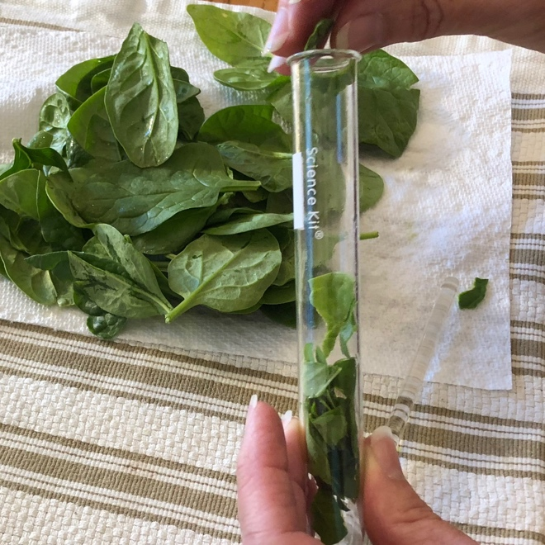
Preparing spinach leaves

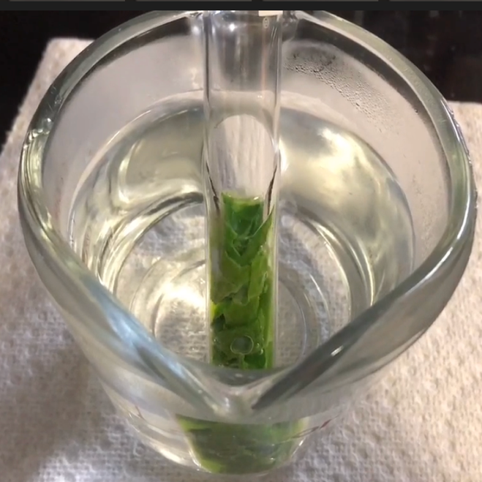
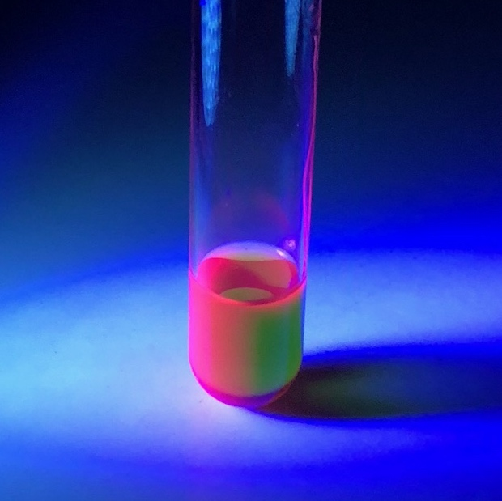
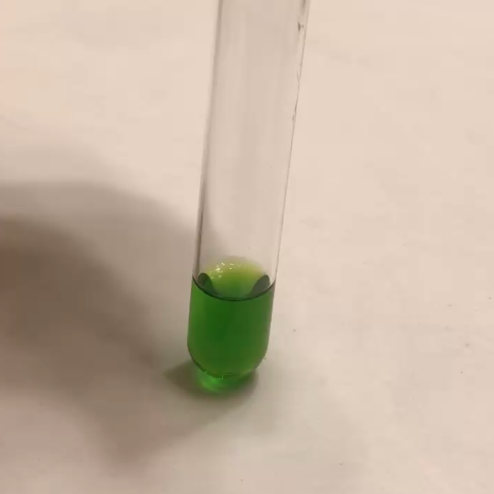
Boiling spinach leaves in acetone

Chlorophyll solution after filtering

Chlorophyll fluorescence with blacklight


TERMS OF USE

©Science Island. All rights reserved by the author.
This purchase includes a lifetime single-teacher license for your individual classroom. The purchaser has the right to reproduce the pages for personal or classroom use only.

Duplication for another teacher, an entire school or school system, or for commercial purposes is strictly forbidden without written permission from the author, Carla Brooks.

Copying any portion of this resource and placing it on the Internet is strictly forbidden and is a violation of the Digital Millennium Copyright Act (DMCA). These items can be found online and downloaded for free by others.

You may...
- Make copies of this resource to distribute to students in your classroom for the entirety of your teaching career. Be sure to check “My Purchases” in your TpT account for updates to this product.
- Purchase additional licenses, at a discount, to legally share this resource with others.
- Post this resource on a password-protected site such as Google Classroom for the use of your students ONLY.
- You may post pictures of you or your students using this resource in your classroom if you tag me @scienceislandeducation on Facebook or Instagram and/or provide one of the following links
  - My TpT store: www.teacherspayteachers.com/store/science-island
  - Science Island Education Free Resources: https://www.scienceislandeducation.com/free-stuff/

Please DO NOT...
- Share this resource, in part or in whole, with others.
- Post any portion of this resource on the internet or any website where it can be downloaded by others.

