Acting Out Action Potentials

Teacher's Guide
Purpose:
The purpose of this lab is to have students use two different kinds of models to demonstrate and act out the movement of ions and the operation of membrane proteins during an action potential.

Background:
The characteristic of excitability resulting from the resting membrane potential of neurons (and muscle cells) allows them to generate a nerve signal or action potential. As the rapid, temporary reversal in charges of the action potential is propagated along the membrane, changes occur in membrane proteins which control the movement of sodium and potassium ions. Understanding the function of ion channels and the sodium-potassium pump in depolarization, repolarization, and the return to the resting state is important to understanding how nerve signals travel and communicate to target cells throughout the body.

Materials and Set up:
- Colored paper, blue, yellow, and green: Print the role cards on colored paper using the same colors as the paper model.
- Sheet protectors or laminator: Place the role cards in sheet protectors or laminate them and punch holes for string.
- String or yarn: Make lanyards for the role cards so students can wear them around their neck.
- Painter's tape, rope, or similar: Mark the two sides of the plasma membrane on the floor or ground, about 12-18 inches apart so students playing the role of membrane proteins can stand inside the membrane.
- Tape: Tape down or hang the "intracellular" and "extracellular" signs on the appropriate side of the membrane.
- Scissors: Cut out the ion role cards ahead of time and supply scissors to each group for the paper model activity.

Helpful hints:
- Key terms students should know before the activity:
  - action potential: rapid sequence of changes in the voltage across a membrane; a nerve signal
  - polarity: difference in charge on opposite sides of the cell membrane
  - depolarization: loss of a difference in charge between opposite sides of the membrane
  - repolarization: restoration of the difference in charge between opposite sides of the membrane
  - hyperpolarization (optional): an increase in the potential difference across the membrane
- Prepare the role cards ahead of time making sure you have one for each student to play.
- Prepare three sodium ion cards for every two potassium ion cards.
- Perform a pre-simulation activity before part 2, the human model.
  - Ask students to get into position to represent resting membrane potential. Try not to lead them too much but let them help each other in determining their proper position and action throughout the activity.
  - Make sure there are at least two sodium ions inside the cell and at least two potassium ions outside the cell.
  - Go through each component of the model and review the protein channels and ion concentrations of the resting potential. The student with the "charge" card should stand inside the membrane and hold the card up to indicate the negative charge.
  - Go through each component and make sure students know the location of the proteins and ion concentrations. And review the roles of the ion channels and sodium-potassium pump.
  - Indicate which direction the action potential will travel and make sure the students are in order so that the action potential will be received by the sodium ion channel first, then the potassium ion channel, and then the sodium-potassium pump last. Remind students that there are many sodium ion channels, potassium ion channels, and sodium-potassium pumps along the membrane, but they are only acting out the changes in one section of the membrane.

Human Model Action Potential Simulation:
Announce these events and wait for students to act out their role. Let them help each other as much as possible. It may take them a couple of times to get their actions worked out, so be sure to repeat the activity multiple times and allow students to change roles, too.

- The threshold stimulus has been received and an action potential is traveling along the membrane and reaches the sodium ion channel. (Student playing the role of the sodium ion channel will turn sideways, lower their arms, and allow sodium ions to cross the membrane into the cell.)
- Sodium ions flow into the cell. (Students playing sodium ions pass through the open channel by walking across the membrane at the sodium ion channel. A couple of sodium ions can remain outside the cell.)
- The charge on the inside of the membrane is reversed. (Student with the charge indicator card flips it over to indicate a + charge.) This is DEPOLARIZATION.
- The peak is reached and the sodium ion channel closes. (The student will return to their original position, facing the outside of the membrane with arms crossed.)
- Potassium ion channel opens. (Student playing the role of the potassium ion channel will turn sideways, lower their arms, and allow potassium ions to cross the membrane out of the cell.)
- Potassium ions flow out of the cell. (Students playing potassium ions pass through the open channel by walking across the membrane at the potassium ion channel. A couple of potassium ions can remain inside the cell.)
- The charge on the inside of the membrane is reversed. (Student with the charge indicator card flips it over to indicate a - charge.) This is REPOLARIZATION.
- The ions must be returned to their original positions by the sodium-potassium pump. The sodium-pumping side will take turns with the potassium-pumping side. The Na+ side moves three Na+ ions from the inside of the cell to the outside. (The Na+ side of the pump will open by turning sideways and leading 3 sodium ions, taking them by the hand, to "pump" them back across the membrane to the extracellular space.)
- The potassium-pumping side moves two K+ ions from the outside of the cell to the inside. (The K+ side of the pump will open by turning sideways and leading 2 potassium ions, taking them by the hand, to "pump" them back across the membrane to the intracellular space.)
- The two sides of the sodium-potassium pump continue to alternate their actions until the ions are restored to their original concentrations at the resting state.

Student Version
Overview: Nerve cells communicate to one another and to their target cells through electrical signals called action potentials. In this activity, you will model the action potential in two ways. In part one, you will use a paper model to demonstrate the movement of ions that occurs during the action potential including depolarization, repolarization, and return to the resting state.
In part two, you will play the role of an ion or membrane protein and act out events that occur during an action potential.

Materials
- Paper model of neuron membrane, ions, and labels
- Scissors
- Ion and membrane protein cards on lanyards

Procedure
Part A: Paper Model
- Cut out the ions and labels.
- Use the paper pieces to label the plasma membrane, membrane proteins, etc.
- Place the ions in the correct positions to show the resting state of the neuron.
- Check your placement with your teacher or another student group before moving ahead.
- Move the ions to show the following parts of the action potential:
- Depolarization
- Repolarization
- Return to the resting state
- Show your model to your teacher before cleaning up.

Part B: Human Model
- Your teacher will provide a role card to each student. When you receive your card, read any instructions on it and review notes or diagrams to determine your position and movements during an action potential.
- When directed, find your position in or along the membrane and play the part of your assigned role.

Analysis and Conclusions
- Describe the ion concentrations on each side of the neuron membrane during the resting state.
- What is the charge on the inner membrane when the neuron is at rest?
- What causes sodium ion channels to open?
- When the sodium channels open, which way will the sodium ions move? Why?
- How does the membrane potential change when sodium ions cross the membrane? What is this event called?
- When the potassium channels open, which way will the potassium ions move? Why?
- How does the membrane potential change when potassium ions cross the membrane? What is this event called?
- What is the function of the sodium-potassium pump?
- Why does the sodium-potassium pump require ATP?
- Label the graph below.
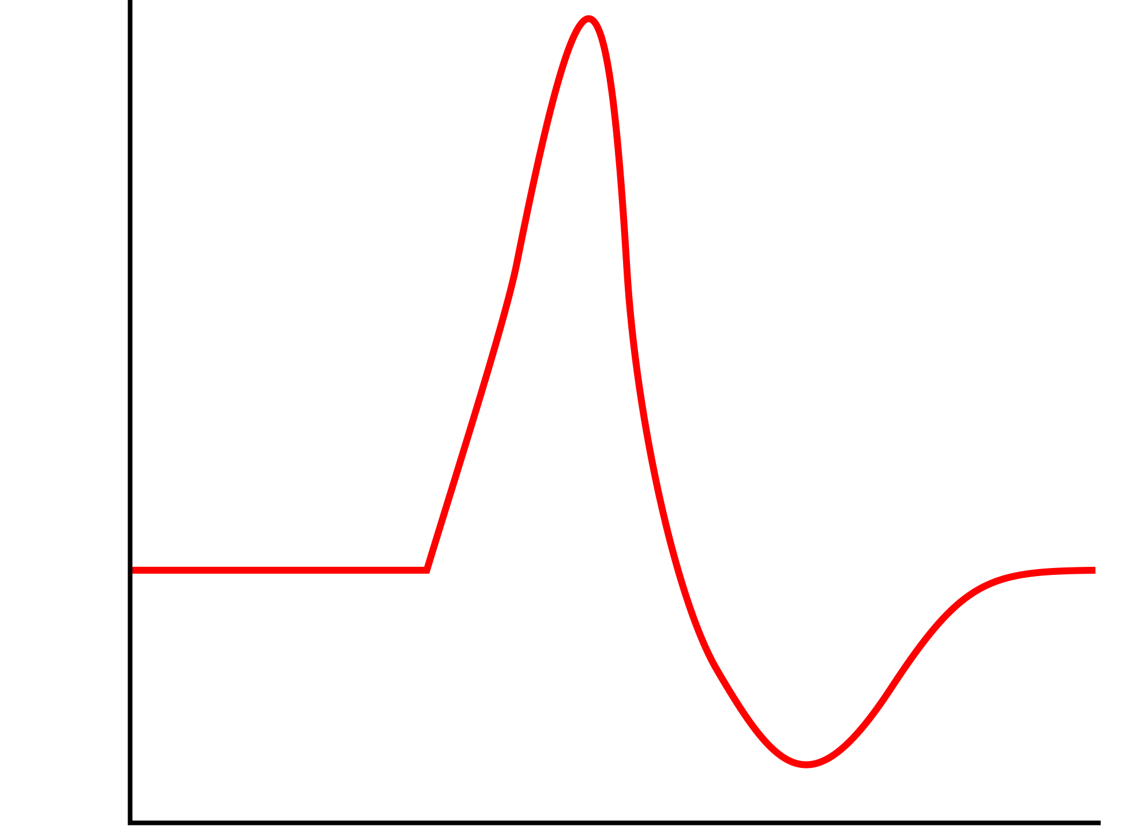

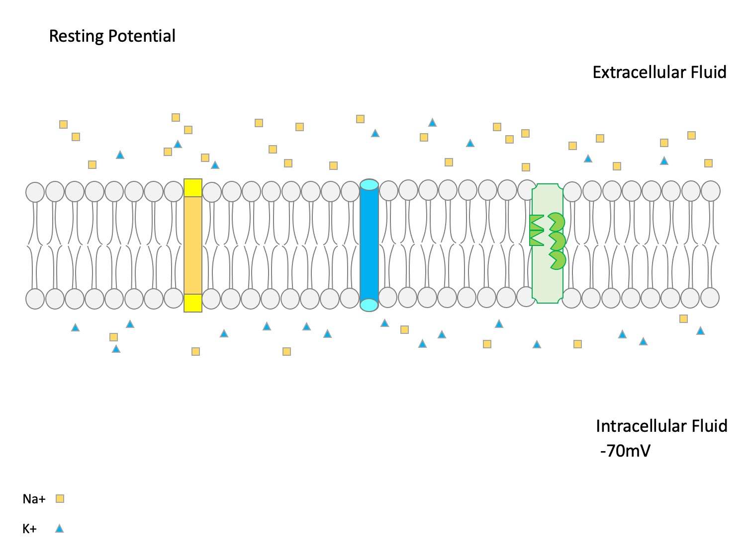
Teaching Diagram
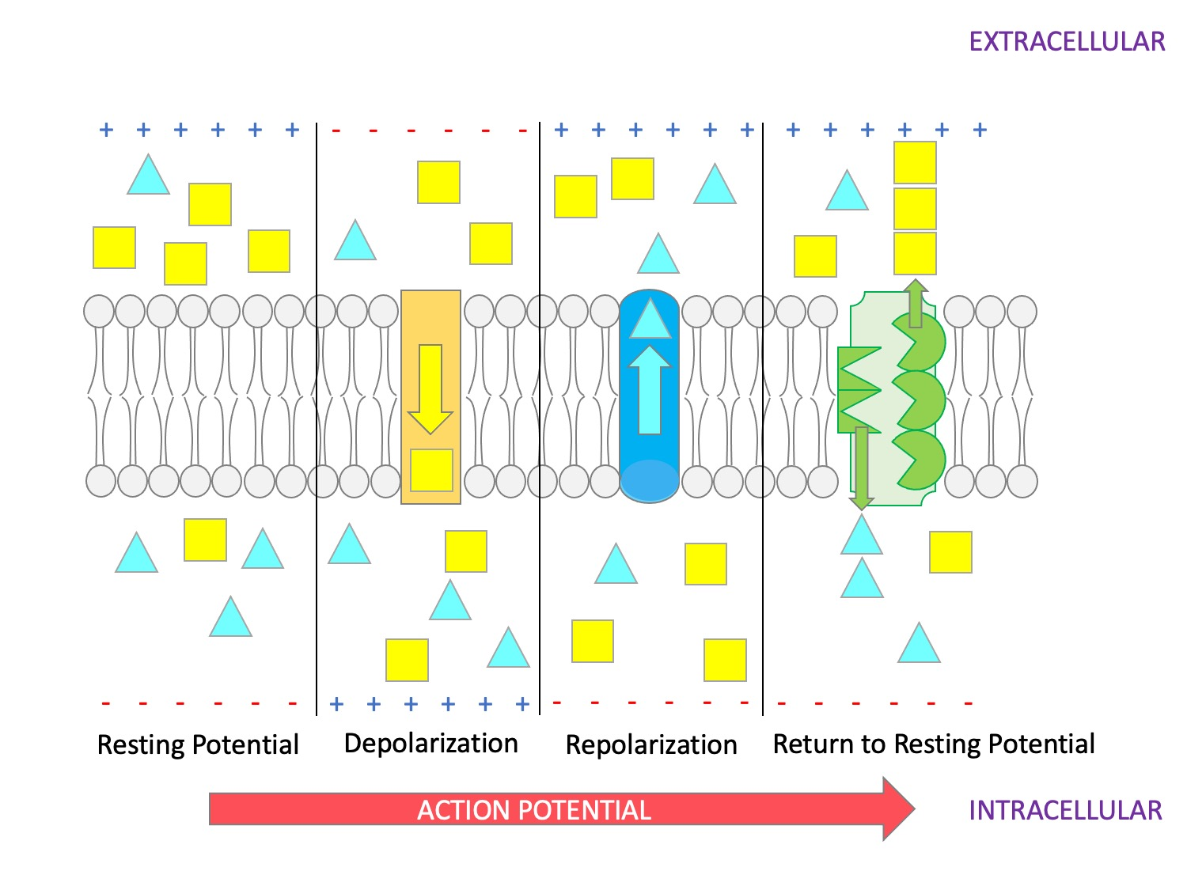
Teaching Diagram
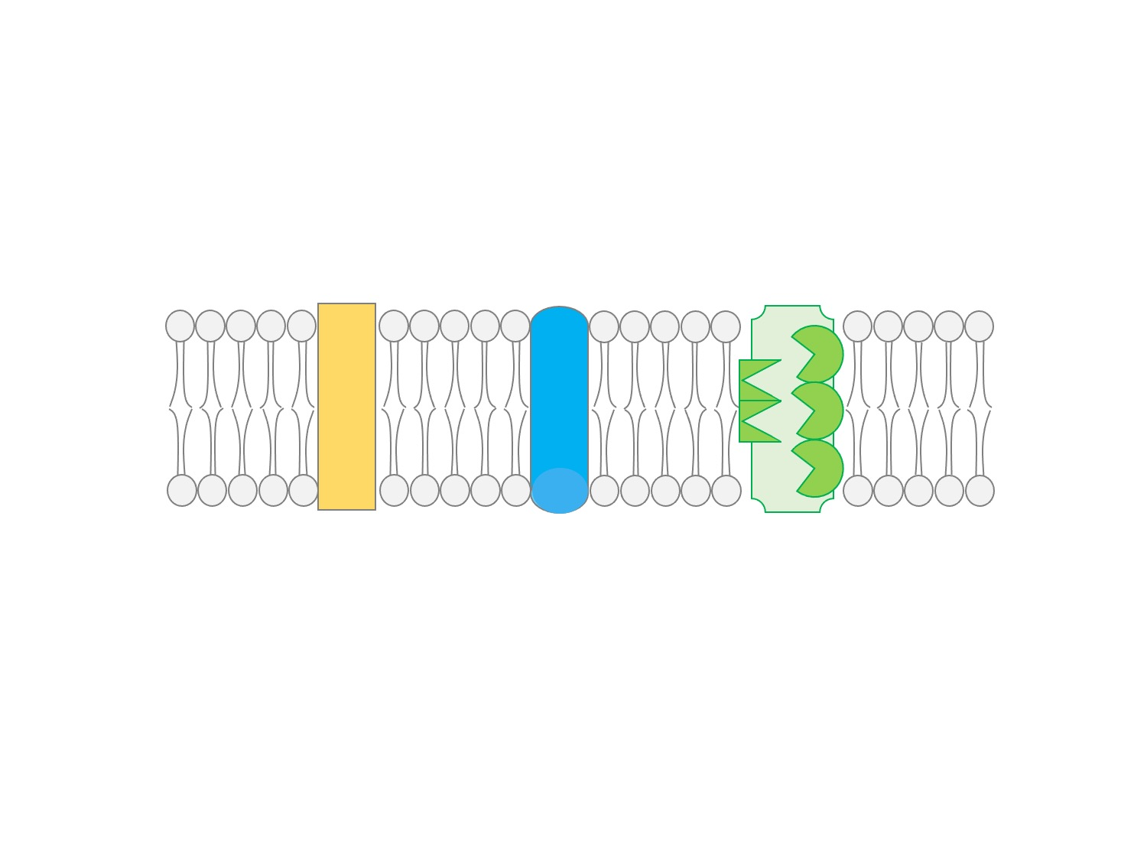
Paper Model, Membrane
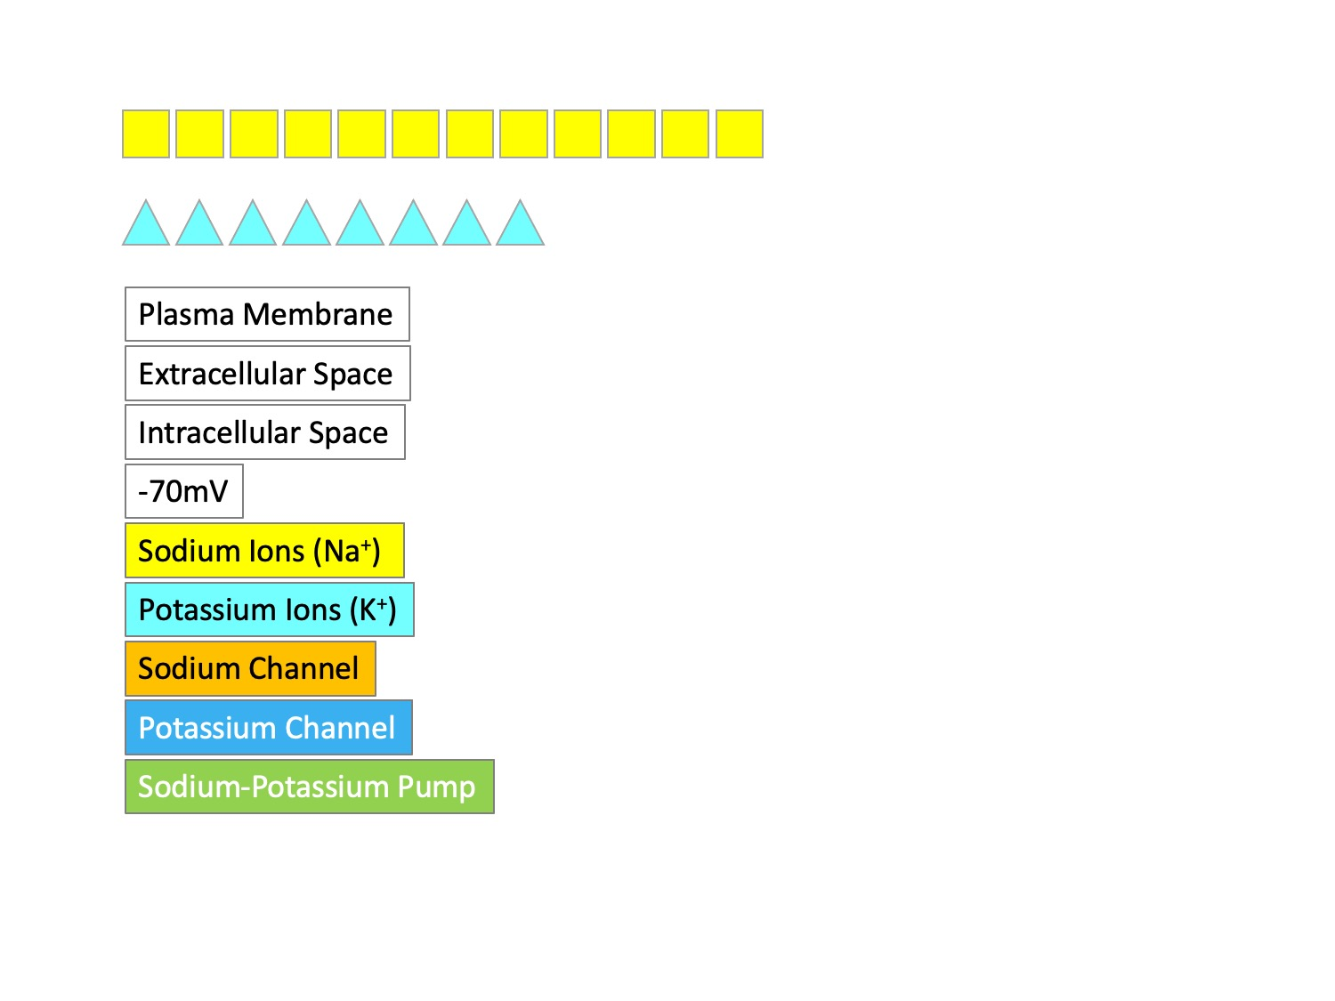
Paper Model, Labels
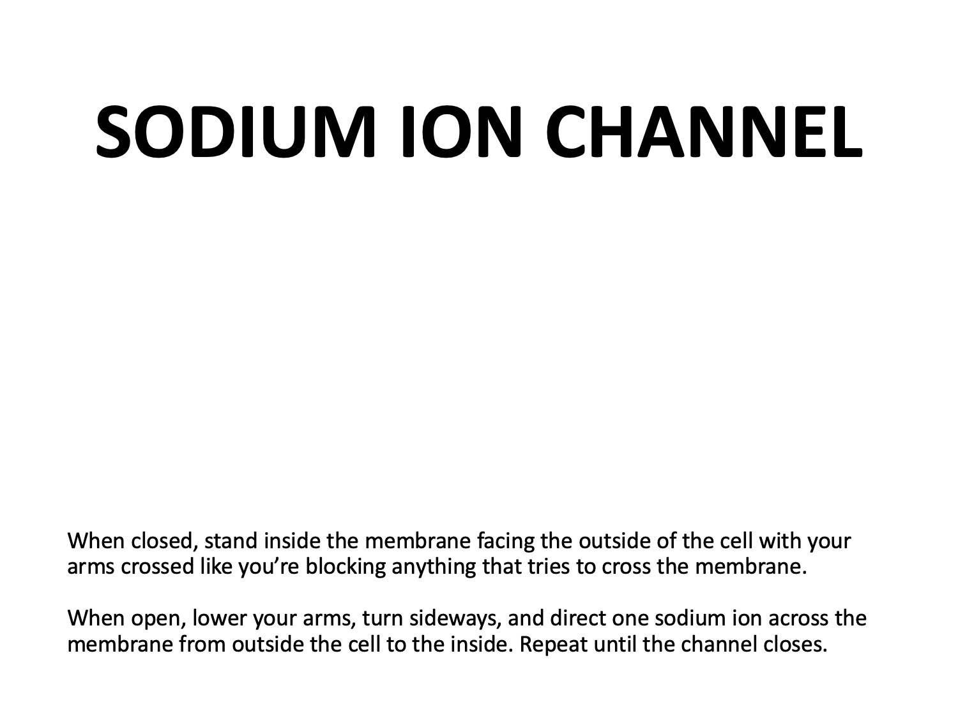
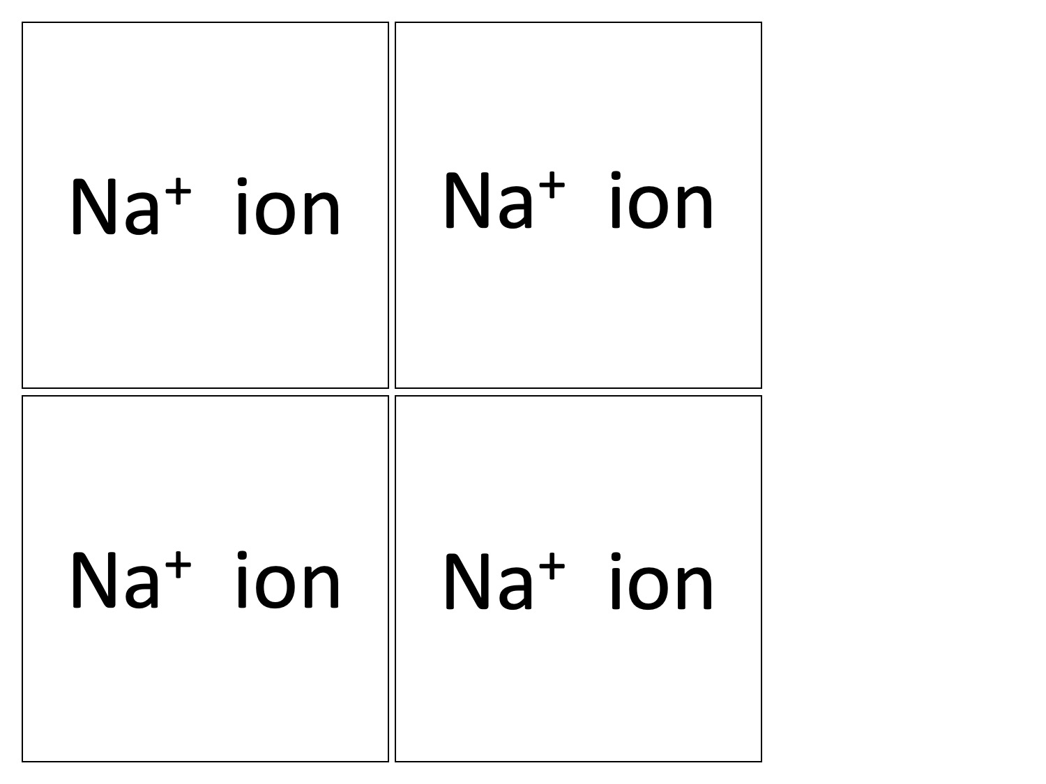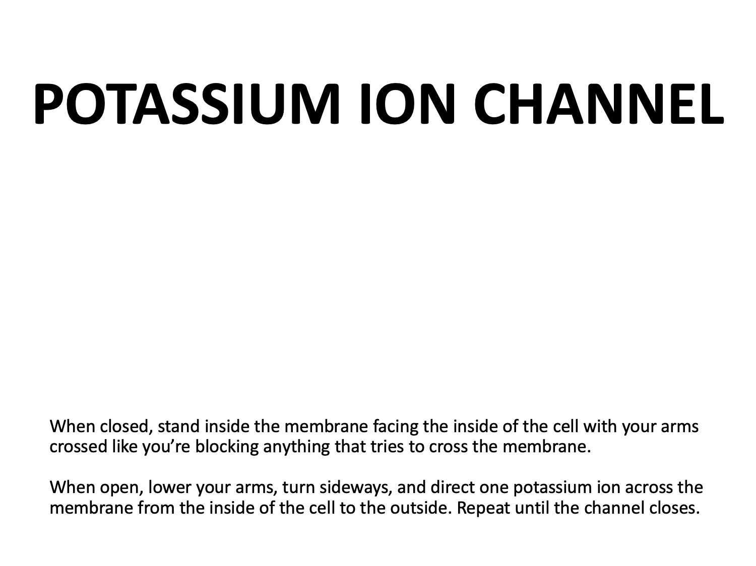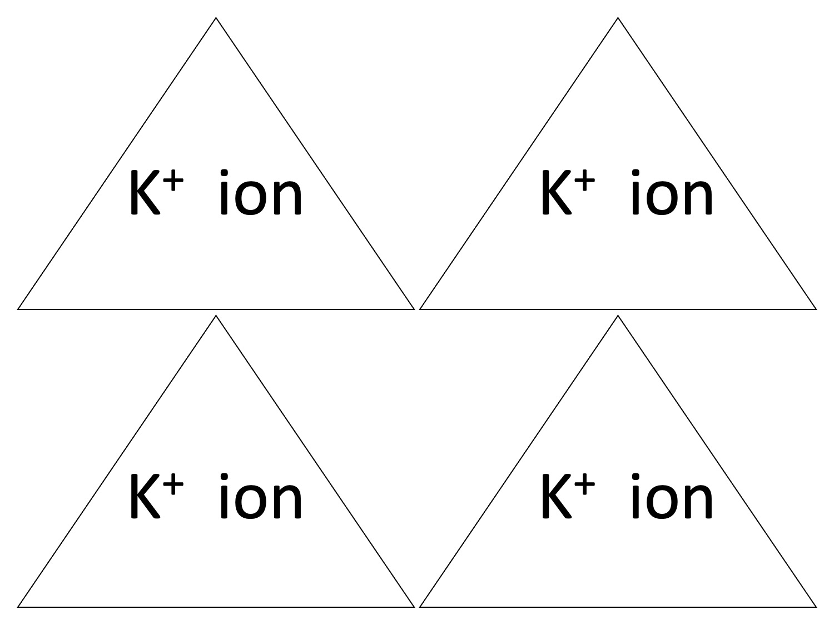
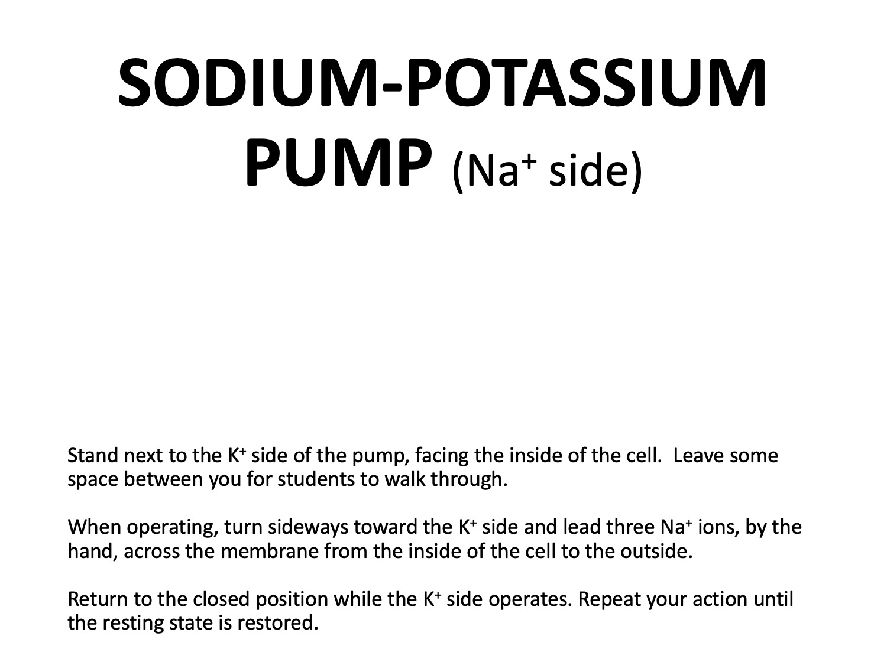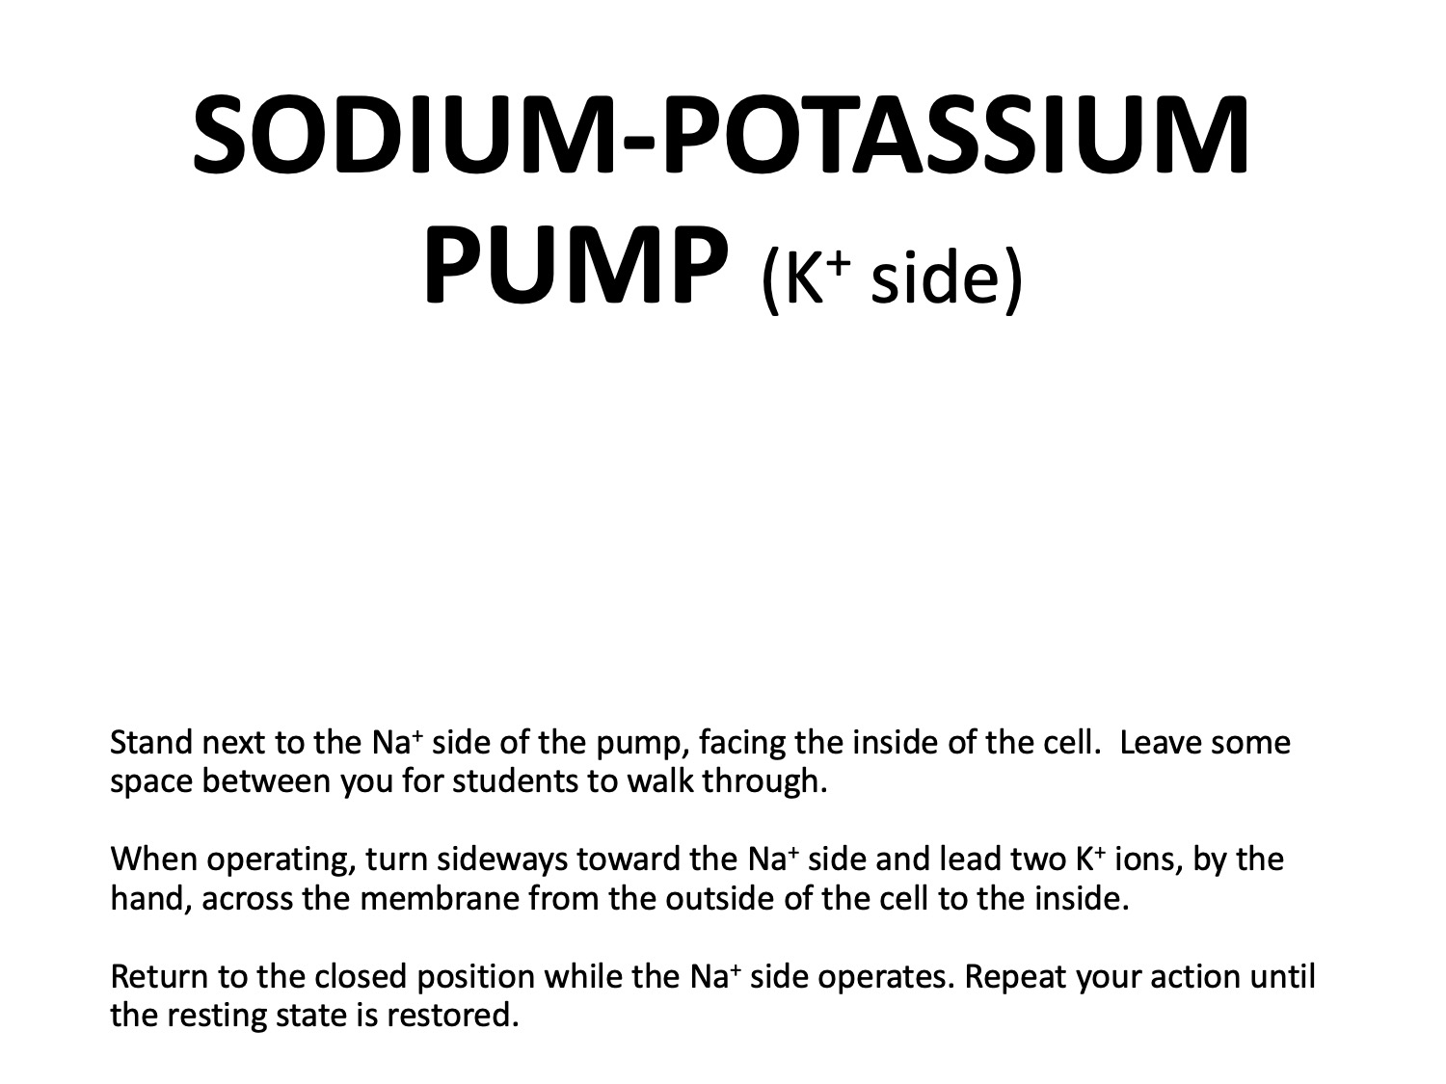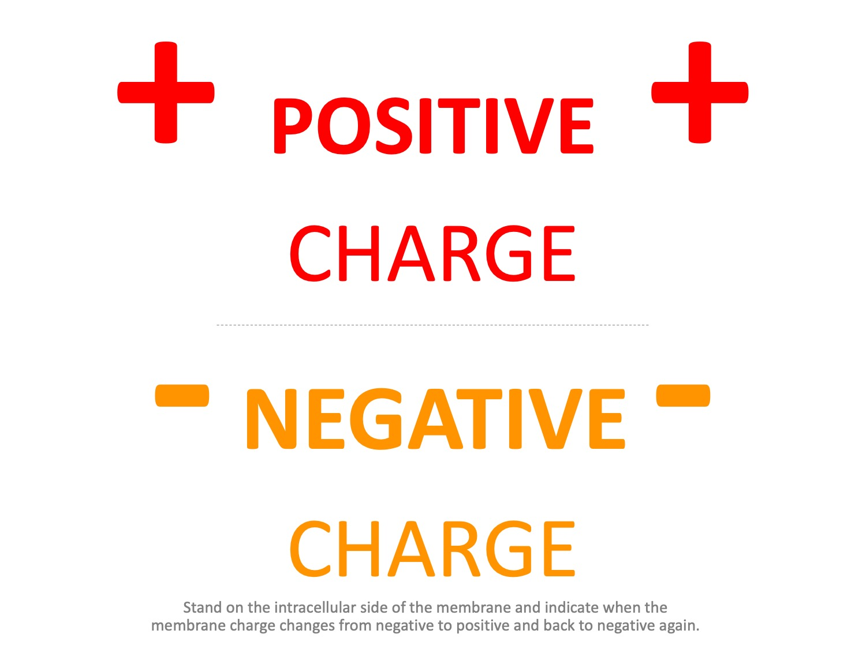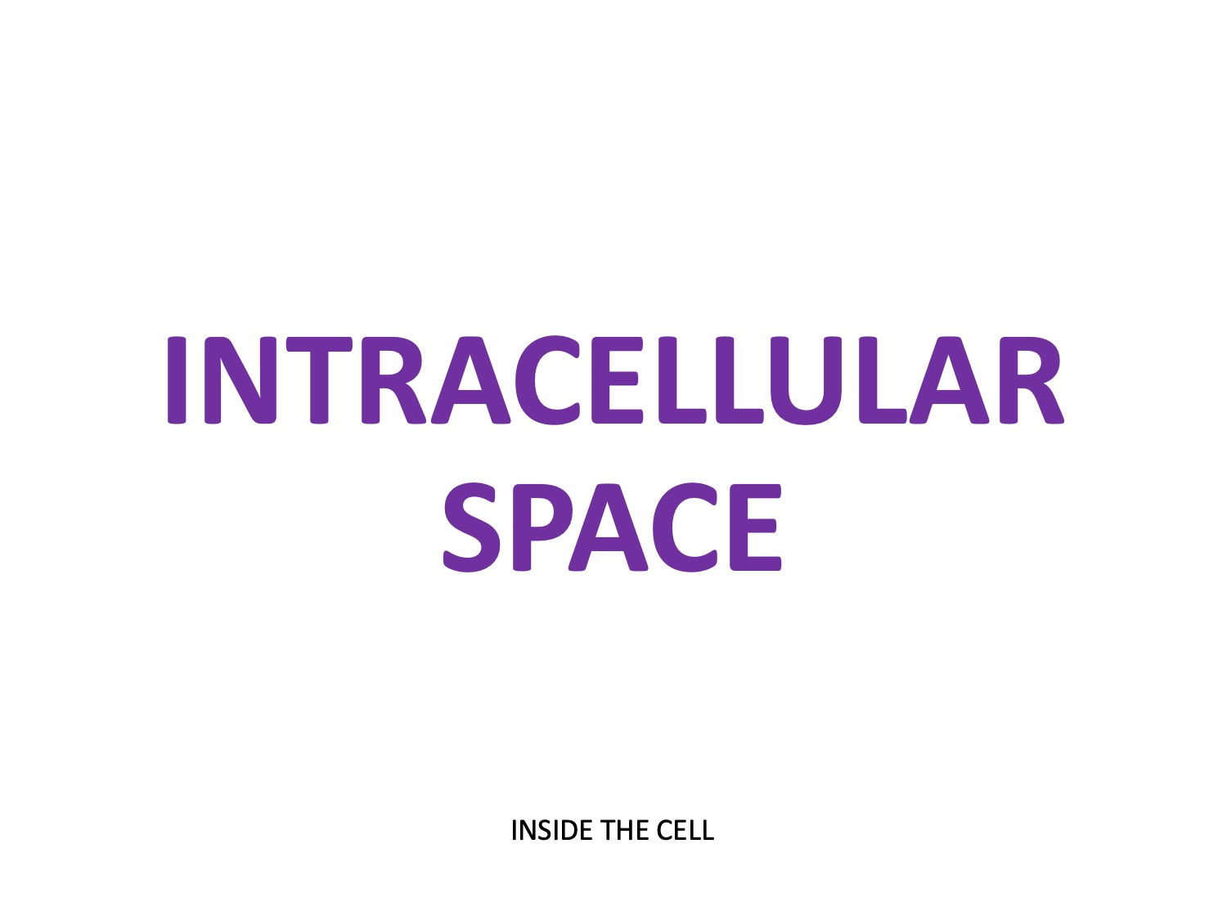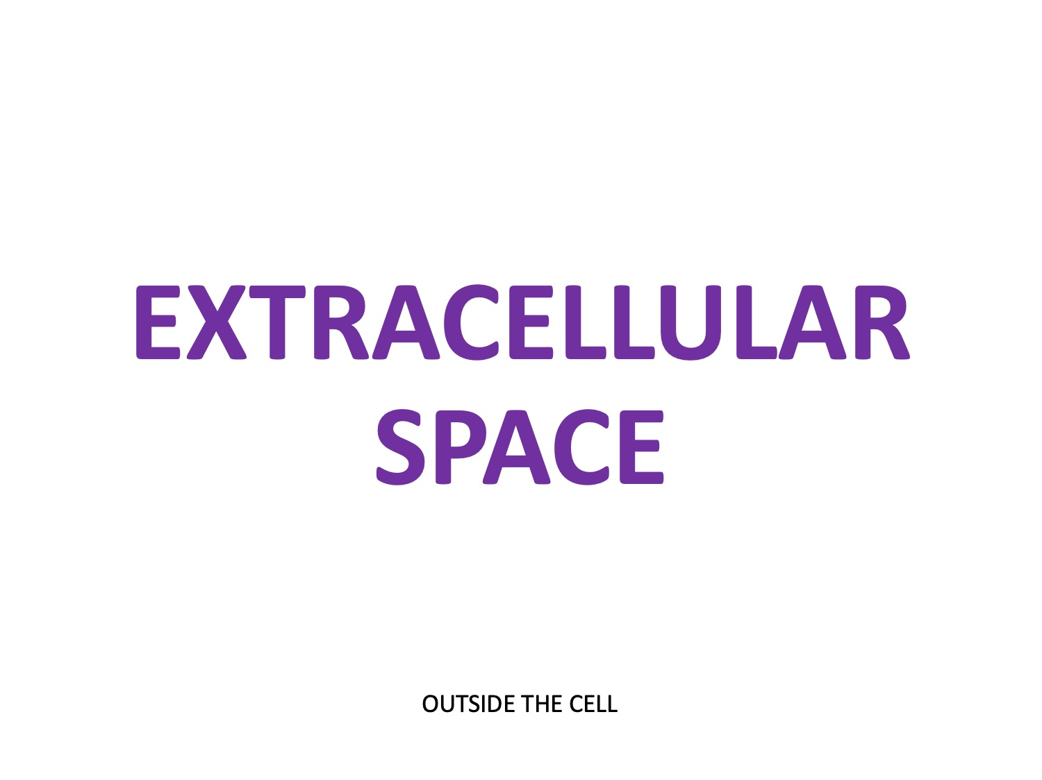Analysis and Conclusions Answer Key
- Describe the ion concentrations on each side of the neuron membrane during the resting state. There is a higher concentration of sodium ions outside the membrane and a higher concentration of potassium ions inside the membrane.
- What is the charge on the inner membrane when the neuron is at rest? -70mV
- What causes sodium ion channels to open? A threshold stimulus will trigger the sodium ion channels to open
- When the sodium channels open, which way will the sodium ions move? Why? Sodium ions will rush into the cell because they move from an area of higher concentration to an area of lower concentration, and the positive ions are attracted to the negative charge on the inside of the membrane.
- How does the membrane potential change when sodium ions cross the membrane? What is this event called? The charge on the membrane becomes positive; this is called depolarization.
- When the potassium channels open, which way will the potassium ions move? Why? Potassium ions will rush out of the cell because they move from an area of high concentration to an area of lower concentration, and they are attracted to the negative charge on the outside of the membrane.
- How does the membrane potential change when potassium ions cross the membrane? What is this event called? The charge on the membrane becomes negative; this is called repolarization.
- What is the function of the sodium-potassium pump? The sodium-potassium pump uses ATP to move three sodium ions out of the cell and two potassium ions into the cell to restore the ion distribution of the resting state.
- Why does the sodium-potassium pump require ATP? Because it is moving ions against their concentration gradient, which requires energy.
- Label the graph below.
