3-D Anatomy Name ________________________
Building a Heart Model Date ________________ Pd_____

Overview
Building models of organs and systems is a valuable exercise in anatomy because it requires you to analyze the details of shape, proportion, and location of the components. Understanding these anatomical characteristics also leads to a more thorough understanding of the function of each body structure.

Pre-Lab Activity: Clay Play Day
Follow the instructions below and use the clay provided to practice modeling techniques. Check off each task as you complete it.

Materials
- Modeling clay
- Work surface such as a plastic mat
- Paper towels
- Clay tools or plastic utensils
- Optional: ruler

Procedure:
- Knead the clay by squeezing it in your hands, between your fingers, and pressing it on the surface of the table until it becomes more flexible.
- Roll the clay into a ball using the palm of your hand on the tabletop. You can also use your fingers to work the clay until the ball is consistently round and smooth.
- Pinch the clay ball into two pieces and work it into two rounds of equal size.
- Knead the two pieces of clay to combine them into one piece again and roll the clay into a symmetrical ball.
- Use your fingers and the palm of your hand to roll the ball of clay on the tabletop until it begins to form a tube-shape or rope. Work to get the clay rope a consistent diameter that is at least 15 cm long (about 6").
- Roll the clay into a ball again. Press it on the tabletop to form a flattened ball or slab of clay about 0.5 cm thick (about 0.25 inches). Use your fingers or the palm of your hand to work the clay until the thickness is consistent throughout the slab.
- Create a pinch pot by pinching the clay in the center and around the edges to form a bowl shape with a consistent thickness.
- Flatten the pinch pot on the tabletop and use tools to cut the clay into shapes (see chart). Use your fingers to smooth the edges of the cut pieces and work to get symmetrical shapes with a consistent thickness.
- Use dry paper towels to remove clay reside from your hands, tools, tabletop, etc.

Task | Complete | Task | Complete
Kneading |  | Slab - consistent thickness
Ball - smooth and consistent |  | Pinch Pot - symmetrical
Pinch and form 2 equal pieces |  | Cut shape - square
Combine 2 pieces into 1 |  | Cut shape - circle
Rope - consistent, 15 cm long |  | Cut shape - triangle

Ball

Rope

Slab

Pinch Pot
Building a 3D Heart Model
Materials
- Modeling clay: red, blue, another color
- Heart Diagram
- Work surface such as a plastic mat
- Paper towels
- Optional: clay tools

Procedure
Part A: Planning the Model
- Discuss with your group which clay shapes you'll need to create for each structure of the heart. List your ideas here:

- Discuss how you want to use each color of clay. List your ideas here:

- Decide which group member will be responsible for building each structure and list the responsibilities below:

Part B: Building the Model
- Follow your plan to build each structure from the appropriate color of clay.
- Use the heart diagram as your guide for the size and location of each structure.
- Answer the analysis and conclusions questions below.
- Clean up according to your teacher's instructions.
Analysis & Conclusions
- Briefly describe how you used the different colors of clay.

- List the vessels of the heart that you included on your model.

- List the chambers of the heart that you included on your model.

- List any other structures or features included on your model.

- Present your model to a member of another group or your teacher. Trace the flow of blood into, through and out of the heart for both the pulmonary and systemic circuits naming each vessel, valve, and chamber as you go.

Get their initials here when complete: _______
- In conclusion, how do you think your model turned out? Do you think this lab helped you better understand the structure and function of the heart? Explain.
3-D Anatomy Teacher's Guide
Building a Heart Model

Purpose
Building models of organs and systems is a valuable exercise in anatomy because it requires you to analyze the details of shape, proportion, and location of the components. Understanding these anatomical characteristics also leads to a more thorough understanding of the function of each body structure.
NGSS Alignment

HS-LS1-2 Structures and Function
Develop and use a model to illustrate the hierarchical organization of interacting systems that provide specific functions within multicellular organisms.

DCI: LS1.A Structure & Function
Multicellular organisms have a hierarchical structural organization, in which any one system is made up of numerous parts and is itself a component of the next level.

SEP: Developing and Using Models
Develop and use a model based on evidence to illustrate the relationships between systems or between components of a system.

CCC: Systems and System Models
Physical models can be used to simulate systems and interactions within and between systems at different scales.

CCC: Structure and Function
Investigating systems or structures requires a detailed examination of the properties of different materials, the structures of different components, and connections of components to reveal its function and/or solve a problem.

Pre-Lab Activity: Clay Play Day
Follow the instructions below and use the clay provided to practice modeling techniques. Check off each task as you complete it.

Materials (see links on last page)
- Modeling clay
- Work surface such as a plastic mat
- Paper towels
- Clay tools
- Optional: ruler

Teaching Tips & Tricks:
- Any oil-based clay, such as Crayola, can be used. Pinch off a section about 3 cm long (about 1-1.5 inches) or about the size of a golf ball.
- Use Ziploc bags or plastic wrap for storing left-over clay.
- Use dry paper towels to clean clay residue off hands, surfaces, and tools
- Plastic utensils such as plastic forks, spoons, and knives can be used in place of clay tools.

Procedure:
- Knead the clay by squeezing it in your hands, between your fingers, and pressing it on the surface of the table until it becomes more flexible.
- Roll the clay into a ball using the palm of your hand on the tabletop. You can also use your fingers to work the clay until the ball is consistently round and smooth.
- Pinch the clay ball into two pieces and work it into two rounds of equal size.
- Knead the two pieces of clay to combine them into one piece again and roll the clay into a symmetrical ball.
- Use your fingers and the palm of your hand to roll the ball of clay on the tabletop until it begins to form a tube-shape or rope. Work to get the clay rope a consistent diameter that is at least 15 cm long (about 6").
- Roll the clay into a ball again. Press it on the tabletop to form a flattened ball or slab of clay about 0.5 cm thick (about 0.25 inches). Use your fingers or the palm of your hand to work the clay until the thickness is consistent throughout the slab.
- Create a pinch pot by pinching the clay in the center and around the edges to form a bowl shape with a consistent thickness.
- Flatten the pinch pot on the tabletop and use tools to cut the clay into shapes (see chart). Use your fingers to smooth the edges of the cut pieces and work to get symmetrical shapes with a consistent thickness.
- Use dry paper towels to remove clay reside from your hands, tools, tabletop, etc.

Task | Complete | Task | Complete
Kneading |  | Slab - consistent thickness
Ball - smooth and consistent |  | Pinch Pot - symmetrical
Pinch and form 2 equal pieces |  | Cut shape - square
Combine 2 pieces into 1 |  | Cut shape - circle
Rope - consistent, 15 cm long |  | Cut shape - triangle

Building a 3D Heart Model
Materials
- Modeling clay: red, blue, another color The other color will most likely be used for myocardium outside the chambers and/or valves
- Heart Diagram
- Work surface such as a plastic mat
- Paper towels
- Optional: clay tools

Teaching Tips & Tricks:
- Laminate the heart diagram or put it in a sheet protector.
- Provide a small amount of white clay if you'd like students to add the heart valves to their model.
Procedure
Part A: Planning the Model
- Discuss with your group which clay shapes you'll need to create for each structure of the heart. List your ideas here: Sample answers
ropes for the vessels and myocardium around the chambers
pinch pots or slabs for the chambers

- Discuss how you want to use each color of clay. List your ideas here: Sample answers
blue clay for vessels and chambers that contain deoxygenated blood
red clay for vessels and chambers that contain oxygenated blood
other color for heart wall, septum, valves
- Decide which group member will be responsible for building each structure and list the responsibilities below: Answers will vary.
Part B: Building the Model
- Follow your plan to build each structure from the appropriate color of clay.
- Use the heart diagram as your guide for the size and location of each structure.
- Answer the analysis and conclusions questions below.
- Clean up according to your teacher's instructions. Don't forget dry paper towels for removing clay residue from hands, tools, work surface, etc. Ask students to separate clay into colors and store it in plastic bags or wrapped in plastic wrap for reuse later.

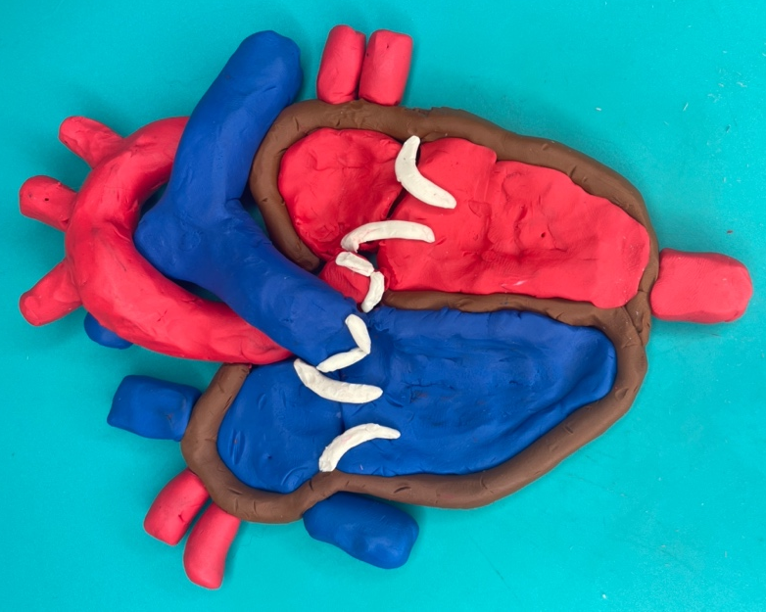

Analysis & Conclusions Answers will vary.
- Briefly describe how you used the different colors of clay.

- List the vessels of the heart that you included on your model.

- List the chambers of the heart that you included on your model.

- List any other structures or features included on your model.

- Present your model to a member of another group or your teacher. Trace the flow of blood into, through and out of the heart for both the pulmonary and systemic circuits naming each vessel, valve, and chamber as you go.
Get their initials here when complete: _______
- In conclusion, how do you think your model turned out? Do you think this lab helped you better understand the structure and function of the heart? Explain.

Anatomy in Clay Systems: https://www.anatomyinclay.com/
Links for Materials:
Clay: https://amzn.to/45kS9CO
Plastic mat work surface: https://amzn.to/3skMM7Q
Clay tools: https://amzn.to/3qJaslV

